Tullygally Primary School


Marking Policy
2024 – 2025


Introduction
At Tullygally Primary School, marking is seen as an integral part of the assessment process. We believe that marking should be positive, clear and appropriate in its purpose. We will ensure that all children have their work marked in such a way that it is likely to improve their learning, develop their self-confidence, raise self-esteem and provide opportunities for self assessment. There will be consistency in the way that children’s work is marked throughout the school.
We believe children are an integral part of the marking process and are given the opportunity to review their own work as well as that of their peers. Our Marking Policy is embedded in the Assessment for Learning Practice which is implemented throughout the school.

Aims of Policy
The aims of this policy are to:
- Address the whole school audience.
- Set out principles which aim to ensure the quality of marking.
- Ensure the staff is aware of the system of marking used within Tullygally PS
- Identify the roles, which each member of staff has in the marking of work

Aims of Marking
The aims of marking are:
- To promote pupils’ confidence and self-esteem.
- To help children improve their performance through constructive comments linked to assessment criteria.
- To provide a dialogue between teachers, classroom assistants and children and give clear appropriate feedback about strengths and weaknesses in their work.
- To use constructive comments to improve pupils’ work.
- To help children to reflect on their learning through self-assessment and self-evaluation.
- To improve children’s confidence in reviewing their own work and setting future targets.
- To provide evidence of assessment.
- To identify children who need additional support or more challenging work.
- To encourage high standards of presentation.

Principles
At Tullygally Primary School, we believe it is important to provide constructive feedback to children, focusing on success and improvement linked to learning intentions and success criteria. This enables children to become reflective learners and helps them to close the gap between what they can currently do and what we would like them to be able to do.

Marking and feedback should:
- be manageable for teachers and accessible to children
- involve teachers/classroom assistants/adults in the classroom giving recognition and appropriate praise for achievement
relate to learning intentions/success criteria/targets, which need to be shared with children
- be regular and frequent and be consistently applied across the school
- give children opportunities to become aware of and reflect on their learning needs give clear strategies for improvement
- allow specific time for children to read, reflect and respond to marking, ultimately be seen by children as a positive approach to improving their learning inform future planning and individual target setting
- marking criteria should be displayed in each classroom and children should understand the meaning of the marks/marking they receive
- children should be involved in self-evaluation and peer assessment and where appropriate be given opportunities to evaluate their own and others work, to make improvement suggestions and to act upon the suggestions made

The Nature of Marking and Feedback

Marking should:
- Relate to the planned learning intention
- Be clear in meaning
- Recognise children’s achievement
- Indicate the next steps in the children’s learning

Feedback should:
- Include all teaching staff and children where appropriate. The teacher is responsible for overseeing all marking that takes place within the class; although when appropriate the Classroom Assistants or children may be involved in the marking process.
- Be given where appropriate on a daily/weekly basis or when a piece of work is completed.

Types of feedback

Verbal Feedback will be given to children daily and will point out successes and improvement needs against the learning intentions. It is interactive and may give reassurance or move the child on to the next learning step. Individual verbal feedback will be indicated on the child’s work with the symbol ‘VF’ and initialled.

Written Feedback will give the children a clear indication about their strengths and areas for development. It will recognise, encourage and reward children’s progress and focus the teachers on those areas of learning where children need specific help. It will use constructive comments to improve the children’s work

Marking for Improvement

All marking is completed in pink and green pen. Pink pen is used for marking correct answers and leaving positive feedback. Green pen is used to ‘dot’ incorrect answers and leave comments for improvement.
All work is marked using:
- I for Independent
- S for supported and it should be initialled by the classroom assistant who has provided support
Foundation Stage
  Mark correct answers in pink |   Mark any wrong answers in green

Key Stage 1
Mark correct answers in pink | Mark any wrong answers in green
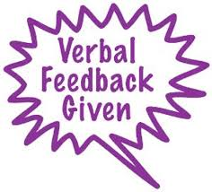  Used when a child has been spoken to about corrections etc. | 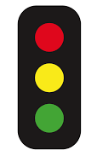  Children colour code their own work for self-assessment using traffic lights.  Red=Hard  Yellow= Okay  Green=Easy

Key Stage 2
Mark correct answers in pink and give positive feedback | Mark any wrong answers in green and give feedback
Use for children who are close to achieving their LI | Used when a child has been spoken to about corrections etc.
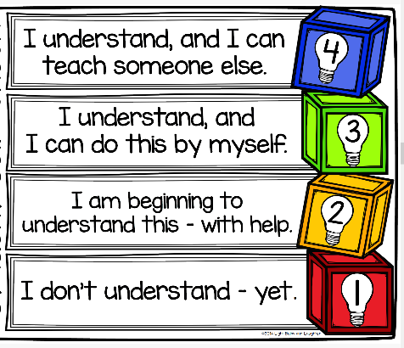
Self Assessment
Children self-assess daily by putting a coloured dot on their finished written work.
Blue – Independent and can help others
Green – Independent
Yellow – Beginning to understand
Red – Doesn’t understand yet

Peer Assessment
Children peer assess of a regular basis but not daily. When they are peer assessing each other’s work the work is stamped using the peer assessed stamper.

Children are encouraged to peer assess using our marking policy of pink and green and always writing something positive in pink first.

Children Responding to Marking:
Children will be given time to reflect on comments given and have the opportunity to make improvements to their work.

Marking for improvement prompts.
Teachers will use three levels of prompts for written comments to help children reflect and improve their work.
- Reminder- reminding pupils of the learning intention and success criteria.
- Scaffold- giving examples of what they could do or asking focused question.
- Example- giving the pupil concrete examples or suggestions that they can use.

It is not always manageable to write marking for improvement comments on all pieces of work completed by the children; it is therefore acceptable to have a target group whose work is marked in more depth than the rest of the class. Groups are then rotated to ensure that all children are given prompts to enable them to improve their learning.

Self Evaluation/Peer Assessment
The use of peer and self- assessment should be a regular feature of learning in each classroom. When giving feedback children should be providing positive feedback to others. As they move through the school they should be supported to learn the skill of providing positive criticism to their peers.
- Children will be trained in the process of self-evaluation/peer assessment. Looking for success measured against criteria and suggesting improvements.
- Children will agree some ‘golden rules’ of response partner/peer assessment/feedback work, to safeguard self- esteem.
- Feedback/peer assessment can be oral or written according to the ability of the child.
- The use of thumbs up, smiley faces or traffic lights may be used by children to demonstrate levels of success as a self-assessment or peer assessment strategy.
- Children will be trained to give an improvement suggestion.
- Children will be given time and opportunity to act upon suggestions.
- The quality of the improvement suggestions and of the peer assessment should be monitored by the teacher.

Monitoring and Evaluating of Marking:
The Senior Management Team and co-ordinators will review samples of work from each class to monitor the implementation of this policy. An analysis will be made and feedback given to staff.
The desired outcomes for this policy are improvement in children’s learning and greater clarity amongst children, staff and parents concerning children’s achievements and progress.

